Zoom resources:
Please note that the items highlighted in grey are copied from a Zoom instruction guide.

Zoom break out rooms:
Breakout rooms allow you to split your Zoom meeting in up to 50 separate sessions
The host can choose to split the participants of the meeting into these separate sessions automatically or manually, and can switch between sessions at any time.
To use the feature make sure it is enabled in your user settings

To manage Breakout Rooms live in a meeting
➡️Click breakout rooms in the meeting toolbar
➡️Select the number of rooms you would like to create, and how you would like to assign your participants to those rooms
➡️Click Create breakout rooms
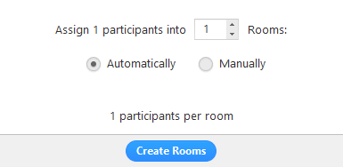
Automatically: Let Zoom split your participants up evenly into each of the rooms.
Manually: Choose which participants you would like in each room
Your rooms will be created, but will not start automatically

After creating the breakout rooms, click Options to view additional breakout rooms options
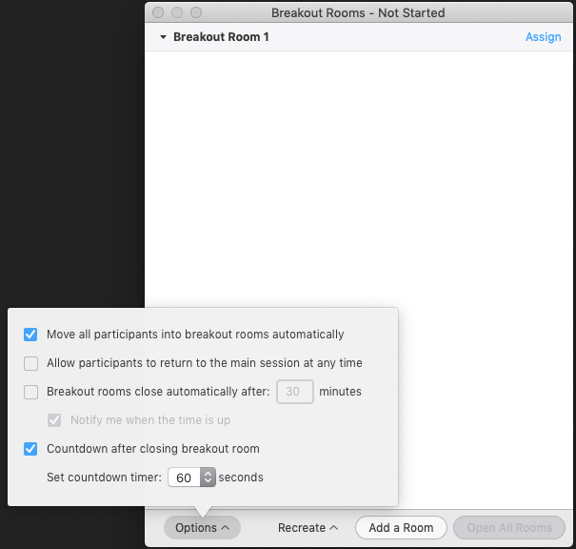

Move all participants into breakout rooms automatically will move all participants into the breakout rooms automatically. If unchecked, the participants will need to click Join to be added to the breakout room.
Allow participants to return to the main session at any time makes it so the participants can move back to the main session from their meeting controls without the room closing
Breakout rooms close automatically after x minutes allows you to set a time when the room will automatically close
Countdown after closing breakout rooms will make it so the participants will be given a countdown of how much time they have left before being returned to the main room.

To assign participants to your rooms
➡️Select Assign next to the room you wish to assign participants
➡️Select participants you want to assign to that room
You can rearrange the participants, add more rooms or delete rooms before starting them
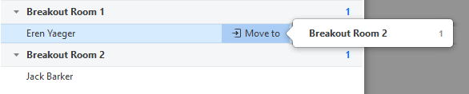
Once you are ready, click open all rooms move users in automatically or allow users to join their assigned room manually, depending on the room settings
As a meeting host, you can split up to 200 of your meeting participants into breakout rooms when scheduling the meeting
You can only pre-assign participants that have a Zoom account
To Pre-assign users that are part of your Zoom account
➡️Go to your User Settings and make sure the Pre-Assign box is checked below the Breakout Room setting.

User Settings

➡️When scheduling or editing a meeting, check the option to Breakout Room pre-assign
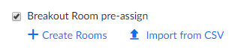
➡️Click Create Rooms
➡️Click the + next to Rooms
➡️Add users to the room by searching their user name or email address

Zoom polling: to enable the feature, on your profile page, click “Settings.” Under “In Meeting (basic), find and enable “Polling”. Now that poling is enabled, you can create a poll.

For a zoom webinar:
To create a poll for a meeting, first navigate to your Webinars page, and click the topic of a scheduled Webinar.
Scroll to the bottom of the Webinar details, until you get to the Poll tab, then click "Add".
Enter a title of your poll, and check if you want the participant answers to be anonymous.
Next, enter your question and then choose if it is a single choice (participants can choose one answer), or multiple-choice (participants can choose more then one).
Type an answer in each row. Once the answers have been filled out, you can click "Add a Question" to create a new question.
Once done creating the polling questions, click "Save".

For a zoom meeting:
To create a poll for a meeting, first navigate to your Meetings page, and click the topic of a scheduled meeting.
Scroll to the bottom of the meeting details, until you get to the Poll tab, then click "Add".
Enter a title of your poll, and check if you want the participant answers to be anonymous.
Next, enter your question and then choose if it is a single choice (participants can choose one answer), or multiple-choice (participants can choose more then one).
Type an answer in each row. Once the answers have been filled out, you can click "Add a Question" to create a new question.
Once done creating the polling questions, click "Save".

Mentimeter: create word clouds, short surveys and polls
www.mentimeter.com

EdPuzzle: Add quizzes to videos (from youtube or your own MP4s)
https://edpuzzle.com/

Padlet- similar to a bulletin board where participants can answer prompt questions on “sticky note” (can upload and include images and videos and hyperlinks)
https://padlet.com

Pixabay: copyright free images to use in your presentations
https://pixabay.com/

Qualtrics: create your own surveys and QR codes. QR code can be shared in a power point slide for participants to scan on mobile device to answer short survey.

